Sketching and Wireframing
Your Project Toolkit

About This Toolkit
How to Use
To get started with this toolkit:
- Click File > Make a copy… in the upper-left corner.
- Give the file a title that includes your first and last name.
- Click OK.
- The toolkit is now saved to your Google Drive account, where you’ll be able to edit it.
Your Project Challenge
In this project, you’ll create three wireframes using a digital design tool (Sketch, Adobe Xd, or Figma), as well as a wireflow design sketched on paper. Then, you’ll write a brief describing the wireflow.

Use this toolkit to:
- Submit your three digitally created wireframes.
- Submit a picture of your wireflow sketched on paper.
- Write a brief describing your wireflow.


Wireframes
Use this space to add your three digitally created wireframes.

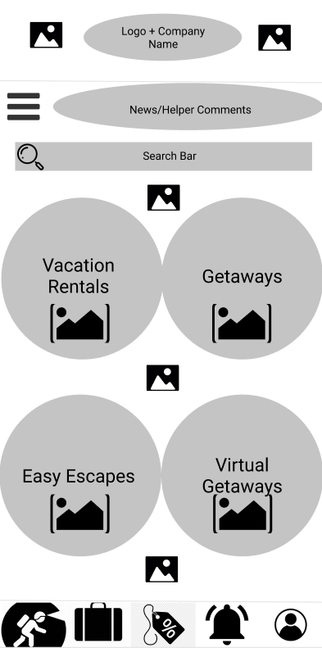
Don’t forget to include placeholders to represent the screens' content and annotations that support communication with team members.
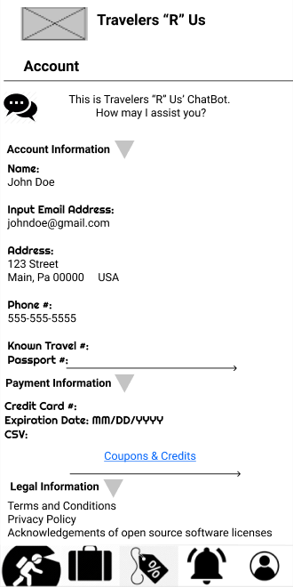
Account Page
Home Page / Explore Page
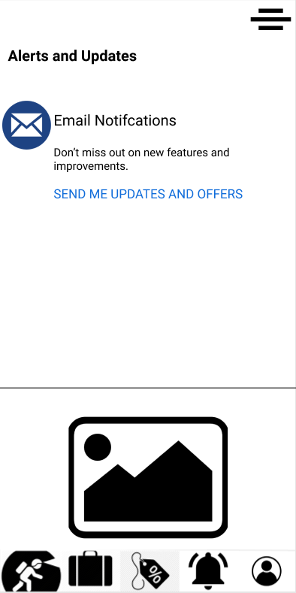
Alerts/Notifications Page

Wireflow
Use this space to add your paper wireflow.

Remember to use your wireflow to show how a user would navigate between the three screens you wireframed, as well as how they would accomplish a task.
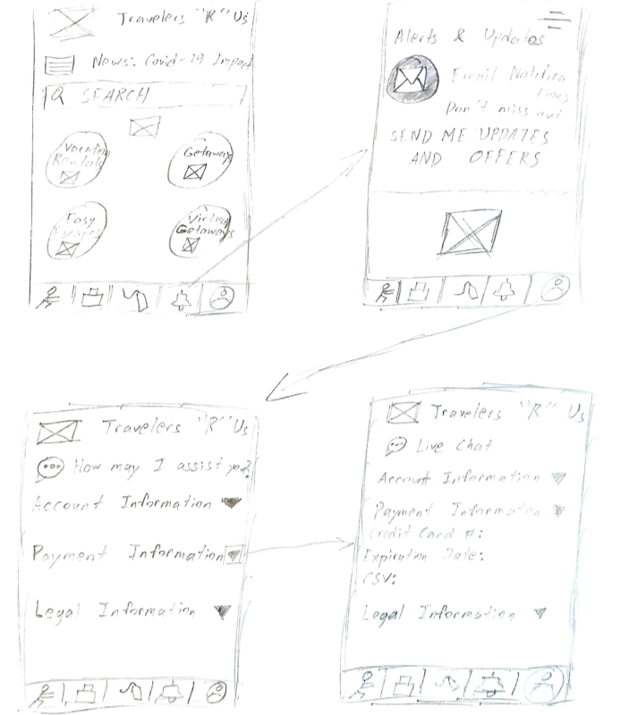

Describe Your Wireflow
Use this space to describe your wireflow.
[How are the interface elements represented in the design?]
For multiple items that a user might need in the future but not currently, I use a triple bar to represent that on the homepage so it’s easy to find and pull up whenever needed.

[What elements of the website or app are prioritized?]
For my app, I try to make it visually appealing along with simplicity with the placement of the buttons.

[Explain any components or interactions you need to communicate as the designer to a fellow designer, engineer, or client.]
Regarding the 5 buttons near the bottom of the app, they each direct you to a “page”. You cannot scroll left or right on the page to access another page. You access page to page using the buttons. The reason for this is to prevent users from misclicking and traveling to another page by accident.

